

Tilsley House Care Home

Information Booklet

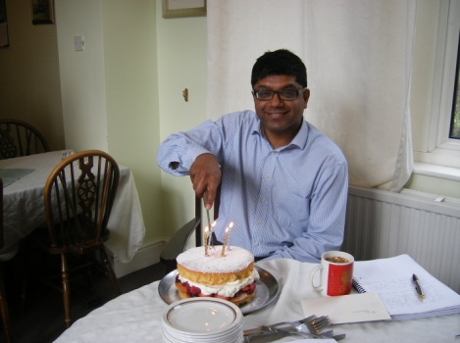

I know that deciding to move into a care home is a difficult decision at the best of times. Prospective residents, their family and friends experience a wide range of difficult emotions.

We at Tilsley House will do all we can to help you through this difficult transition and help residents settle in quickly and happily.

At Tilsley House we do feel that for many older people, moving to a care home can provide considerable benefits: to have full time care; to be in the company of others to take away the loneliness; to enjoy regular tasty, varied and nutritious mealtimes with friends; to have the opportunity to participate in a full range of activities to keep mind, body and soul active according to the individual’s interests and capabilities.

Our fully trained staff look after every individual as if they are an individual and not as someone on a factory line. We believe we can make a difference to every one of our residents by providing personalised care and attention in an environment filled with love, warmth and security.

Tilsley House is a lovely and homely care home; we only have 30 bedrooms. We take great pride in our building and spend a considerable amount of effort in its upkeep.

We like to think that the staff and residents together, are like an extended family.

We would be delighted to show you round our home.

Rizwan Govindji, Company Director

Words from Our Senior Management Team...

Words from Our Senior Management Team...

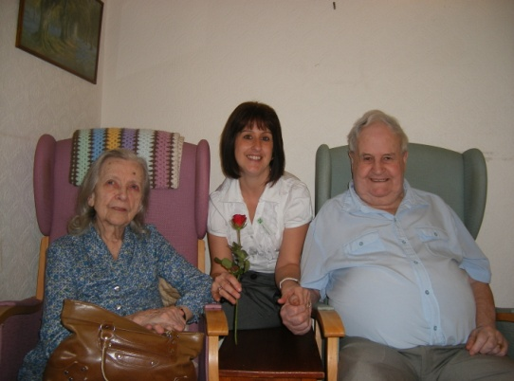

Thank you for your enquiry regarding our home, Tilsley House. As the Home Manager I feel it may be appropriate to give you a little bit of background about me and the home.

I have been working in care for the past 17 years in a variety of roles. I have worked my way up to Management level with Tilsley House being the first home I have run. Before taking on this role I have worked as a carer, spent a number of years as a deputy manager and worked my way up to a Level 4 NVQ qualification as well as having numerous years of experience in the business. I am very privileged to be a part of Tilsley House Care Home and we all strive to provide a high level of care for all of our clients who become our extended family.

Our aim here is to keep your loved one safe and secure in a loving environment maintaining as much of their independence as possible and continuing their daily lives and connections within the community.

Personally I feel that an open door policy is necessary in any home and I always encourage people to feel at ease to come and speak to me with any problems or even just for a general chat. I regard the care of our residents as of paramount importance and do my very best to ensure they are cared for at no less a standard than I would expect for my own flesh and blood.

We hope on viewing our home you get a feel for the work that we do to enhance the lives of our residents. If you have any questions regarding the home or the care that we provide please see in this booklet of how you can reach me—I am always happy to help!

Claire Conway, Home Manager

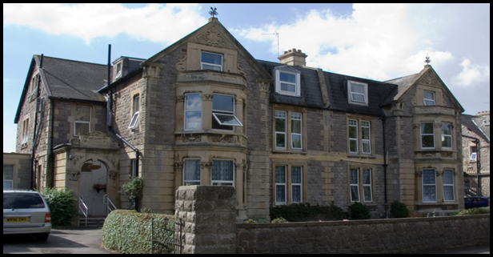

Contents Page...

**About Tilsley House.............................................**4

**Solomon Care Limited Company..........................**5

**Services—Residential Palliative Care**.......................6

**Services—Day Care & Respite..............................** 7

**Services– Fees & Care Charges............................**.8

**Activities.............................................................**9

**Catering.............................................................**12

**Typical Daily Routine.........................................** 17

**Help & Information...........................................** 18

**Choosing a Care Home.......................................**19

**Contact Us.........................................................** 22

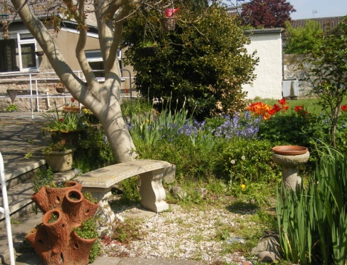

About Tilsley House...

Tilsley House is a lovely home which started life as a care home in the 1980s. Over the years the Home has been extended and modernised to meet both demand as well as legislative requirements.

The Home enjoys a favoured location, overlooking the lovely Clarence Park and a few minutes walk to the beach front. Local shops and amenities are within easy reach, as is access to public transport.

Tilsley House is ideal for residents seeking quality care in a tranquil environment, whilst at the same time being able to enjoy the activity of normal, daily life. Our accommodation is on 3 floors and provides for 30 residents in single rooms. All rooms are decorated and equipped to a high standard and we encourage guest to bring some of their own items of furniture, if they so wish, in order to familiarise their personal space.

We provide long and short term care facilities, and pride ourselves on the quality of service and care we provide 24 hours a day. You can be assured that your care will be managed and delivered by a professional team of trained staff.

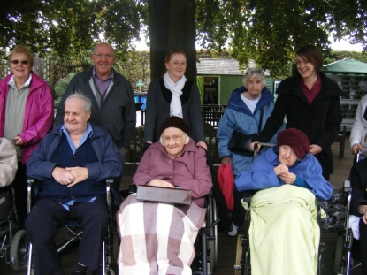

Solomon Care Limited

Our aim is to provide our Residents with a Home in a community setting. Every effort is made to encourage you to remain independent. We will do all we can to provide you with dignity, privacy and respect, ensuring that your spiritual, physical, medical and psychological needs are met in a holistic manner.

You have your own personal Care Plan which is prepared with your involvement, other members of the family and/or those with responsibility for your health, care and welfare. We recognise that each individual is different. Therefore your care plan will be reviewed at least once a month to determine the most suitable care for you personally. This ensures that all our residents are being cared for in the most effective way at all times.

A continuous process of training and development of our staff, and the implementation of industry wide best practice will help to ensure that each resident is getting the best care and service.

You will be encouraged to exercise choice, and procedures are in place to ensure you have access to professional advice and support, where required.

We will encourage, and respect, your right to make and maintain friendships, pursue your hobbies, interests and leisure activities.

**Although we hold a number of Christian prayer meetings and religious practises, we welcome residents whatever their faith, beliefs, values or backgrounds. We will make every effort to allow you to practice your faith.**

**We will try to take into consideration any dietary, clothing and other needs and preferences you may have.**

**This Welcome Pack and Resident Guide must be read in conjunction with the Statement of Purpose of the house which is included.**

**Please note that unless medication is prescribed by a GP, relatives and friends must not bring in any forms of medication purchased over the counter. No medicines must be kept in residents’ rooms unless the resident is able to self medicate.**

Services: Residential &

Palliative Care

## 

The home can excellently accommodate residential care. We provide a range of activities where residents can interact with one another and with staff on duty, we encourage outings and most importantly aim to maintain each individual's independence. Tilsley House is a home and not an institution - where able, we hope residents are able to go on trips or even on a wander down to the shops, the beach or just across the road to the local park.

We aim to stimulate our residents and to personalise the care given to them as much as possible. We also actively encourage family and friend involvement and try to include everyone as much as possible as we map out the best form of care tailored to suit needs, wishes and preferences.

We also offer excellent palliative care under the guidance of District Nurses in a calm and homely environment which is tailored to suit the needs and preferences of the individual.

Our Home Manager, Claire Conway endeavours to cater for all needs and preferences and works well to implement your care needs and wishes and to make smooth and happy transitions into care. Her 20+ years experience and caring nature is a big reason why our home is successful, friendly and of course well managed.

Services: Day Care & Respite

Tilsley House designs care packages which suit individuals, families and carers.

We offer special rates for day care or respite stays for breaks or to try out life in a home. We have great feedback from current respite and day care residents and can offer extras such as meals, provision of personal care and bathing or just a chance for individuals to mix with others and take part in activities and events.

We are also host to a number of open days and events in which we encourage participation of others in the local community. We enjoy allowing our residents to socialise with others and to give others a taste of the high standards of care that we deliver at Tilsley House.

Our day care and respite services have been highly recommended by previous residents and we have had many individuals visit us on one occasion for a break from home or to give other carers some time off.

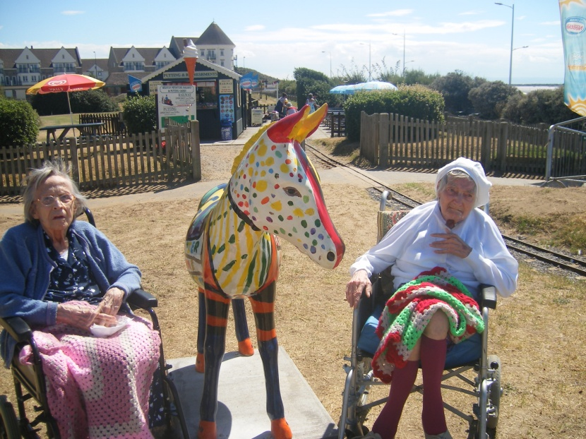

Here at Tilsley House, we pride ourselves on our fair and competitive prices within the local area. Our fees system operates on a conditional basis to suit the needs and preferences of our residents. Therefore a basic weekly rate is provided and extra provisions added or removed as necessary.

We accept a basic social services rate of £390 per week in line with North Somerset Council. Our basic private rate currently stands at £410 per week and our basic rate for respite care is currently £445 per week.

Payments may become subject to a top-up payment depending on a number of premium services which we offer:

**En-suite premium of £35 per week**

**Deluxe room premium of £35 per week**

**Care premium of £35 per week**

A basic set fee covers costs of personal and any one-to-one care, provision of meals and other food at the request of each individual, laundry and room supplements and many of the activities/entertainment which we provide.

We offer services such as chiropody, hairdressing and external clothing providers at a small additional charge.

Services: Fees & Care Charges

Our home has a brilliant balance of in-house and external visitors in order to provide stimulating and enjoyable activities for our residents.

We have a range of group and individual exercises from sing-a-longs to basic exercise, quizzes, movie evenings and planned events.

We review our activity programme often to cater for the wishes of our residents and believe that providing a motivating and exciting environment greatly enhances the quality of life for all involved. We encourage visitors, relatives and friends to participate in activities and outings as much as possible.

Please see overleaf a typical activity programme (four weekly) which is utilised in the home.

Activities

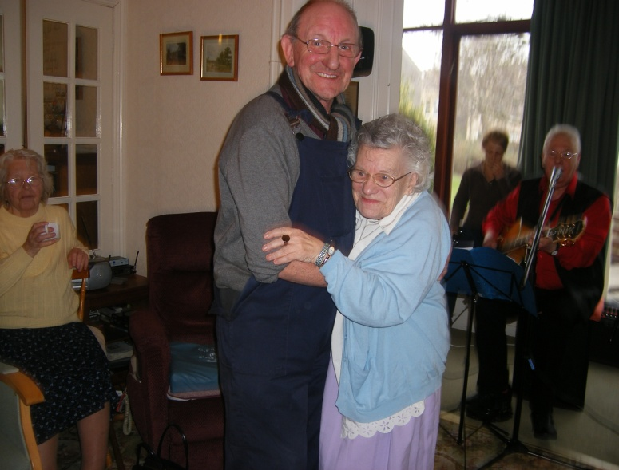

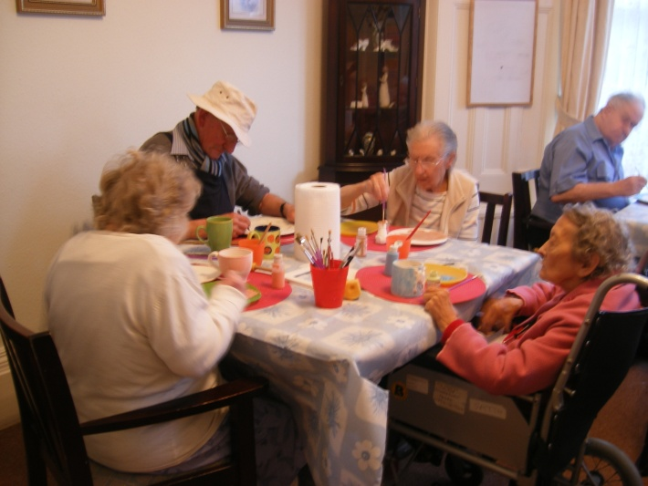

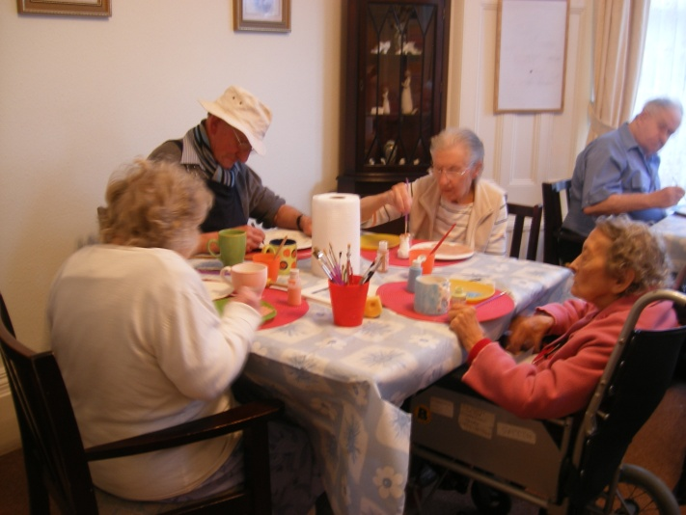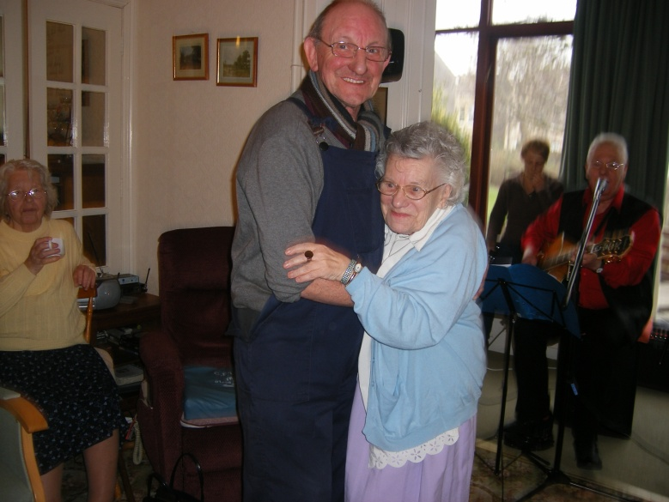





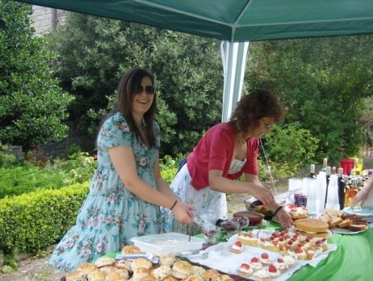

Catering

Tilsley House is prominent for its nutritional catering service and home-made specialities. We have a specialist catering manager and well developed catering team who have designed a delicious four-weekly menu on the basis of what our residents have asked for. This is reviewed on a seasonal basis and is developed by the catering team, professional guidelines and residents of the home.

Please see overleaf copies of current menus used in the home...

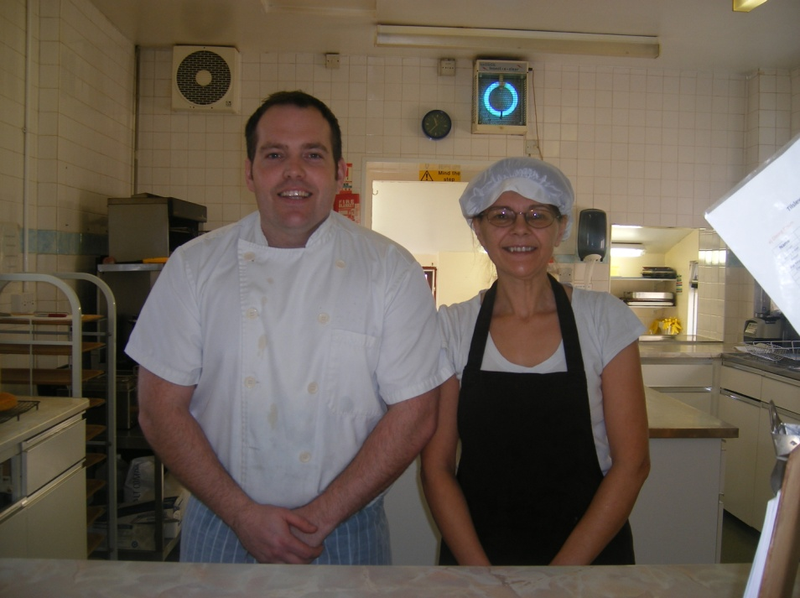

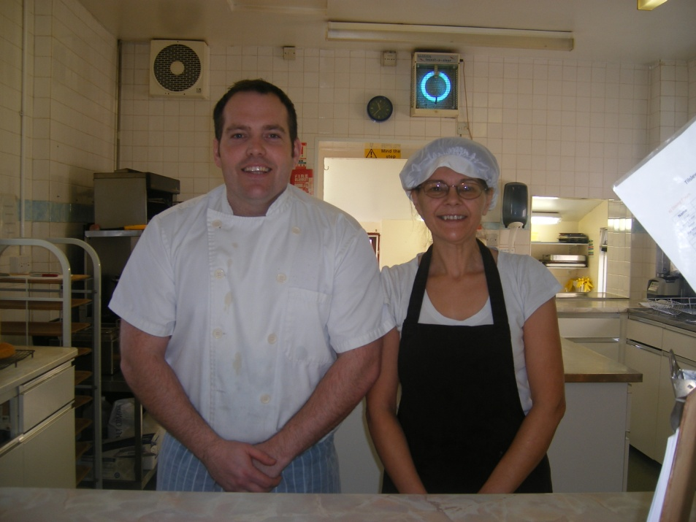



Typical Daily Routine

7.15 am Early morning tea (optional)

8.00 am Breakfast served in dining room/where preferred

10.00 am Devotions in the lounge

10.30 am Mid-morning drinks

12.30 pm Lunch served in the dining room

1.30 pm Tea/coffee in the lounge

3.30 pm Afternoon tea

5.00 pm Tea served in the dining room

8.00 pm Evening drinks

Staff organise a variety of activities for residents to participate in if they wish. These range from craft and gentle exercise whilst others help to stimulate the mind. We also organise monthly trips for residents for those who wish to go on outings.

Residents are free to go into the garden or venture further afield either on their own if physically able or with family and friends. We encourage our Residents to maintain certain levels of physical movement in conjunction with their ability.

**Care Quality Commission (CQC)**

Information regarding Tilsley House can be accessed on www.cqc.org.uk along with a link to our recent inspection reports for your information.

If you have any queries or would like additional information on our home or the services we provide please contact our home manager or relevant persons (contact details can be found at the end of this information booklet).

**Feedback**

The quality of care which we provide is central to all that we do at Tilsley House. In order to continuously improve our service we encourage feedback from all those associated with our home. As part of this evaluation we would like to consult with you and your family to obtain information regarding your opinions and impressions of the Home, the staff and other aspects of your care and residence here.

We would be grateful to hear your comments and feedback either by post, telephone or e-mail.

**Useful Websites**

Some of the following websites may be useful to you in looking for a suitable care home or advice on the care profession, fees and other queries that you may have.

• North Somerset Council: http://www.n-somerset.gov.uk/Social+care/

• Skills for Care: http://www.skillsforcare.org.uk/home/home.aspx

• Age UK: http://www.ageuk.org.uk/home-and-care/care-homes/

• Social Care Institute for Excellence (SCIE): http://www.scie.org.uk/

Help & Information

Choosing a Care Home

Checklist

# See below examples of questions and facilities that you may need to know about...

# Location

Is the home easy to get to for relatives and friends? Is it on a bus route? Does it have car parking?

Is the home close to public transport and local amenities such as shops, churches or pubs?

Are the surroundings too noisy?

Are there interesting things to see outside?

Are the views pleasant?

# Accommodation

Is the home well decorated, bright and cheery?

Is the home clean with attractive decor?

Does it feel safe and secure or can people wander into the home?

Is there useful equipment, such as lifts and specially equipped bathrooms?

Is there wheelchair access indoors and outdoors?

Are there handrails in hallways and corridors?

Do residents have their own room and washing facilities?

If sharing, is this organised to your satisfaction?

Are bathrooms located conveniently for the rooms?

Is the call bell system accessible?

Is there a pleasant outlook from the bedroom window?

Can you open the windows in the room?

Can personal possessions be accommodated, or a pet?

Are there telephone and television sockets?

Can you have your own telephone with a separate number?

Are there communal lounge areas both with and without televisions?

Is there a separate dining room?

Can you have your own door key?

# Facilities

Are a variety of activities and outings available?

Can valuables be secured and are personal possessions insured?

Are the arrangements for laundry and room cleaning satisfactory?

Is sufficient medical help available?

Can residents have their own GP?

Does a chiropodist/physiotherapist/hairdresser/dentist/optician visit regularly?

Does someone bring library books?

Can the home find you the time and space to pursue your present interests and hobbies?

Does the home provide transport?

# Catering

Can you join residents for a meal as part of your visit?

Is there a choice of menu?

Are special diets catered for?

Is the choice of food interesting, varied and good quality?

Can you choose to take meals in your room if desired?

May your visitors join you for refreshments or meals?

Are meal times flexible?

Is alcohol available if you would like it?

# Daily living

Do you know some of the existing residents?

Are the staff friendly and caring?

Do residents look happy and well cared for?

Do staff receive training?

Are there adequate staff on duty day and night?

Does each resident have their own personal care plan?

Are there set times for getting up, going to bed, or having a bath, or can you choose?

Are visitors welcome at all times?

Is there somewhere to see visitors in private?

Is there a garden and can residents use it?

Is there somewhere you can get privacy and peace and quiet, other than your bedroom?

Can you follow your religious practice e.g. attend church services or can a Minister visit you?

# Type of care

Does the home offer the level of care you need?

If you have a particular condition, does the home have the right experience and staff?

How well qualified is the Care Manager?

If you want to, can you or your relatives speak directly with the owner of the Home at any time?

# Fees

How much are the fees?

Is it clear exactly what is included in the weekly charges?

Will the home accommodate you on state support?

Will the home provide a written contract of the care provided?

**NOTES**

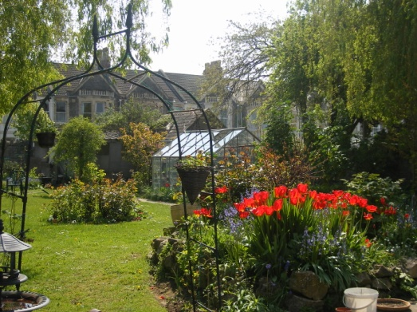

**Tilsley House Care Home**

**Postal Address**

14-16 Clarence Road South

Weston-super-Mare

North Somerset

BS23 4BN

**Telephone Number:** (01934) 626933

**Fax Number:** (01934) 637843

**Website**

www.solomoncare.com

**E-mail Contacts**

General Enquiries: info@solomoncare.com

Home Manager: claire@solomoncare.com

Deputy Manager: vicky@solomoncare.com

Admin Manager: aimee@solomoncare.com

Catering & Activities Manager: jamie@solomoncare.com

Contact Us

