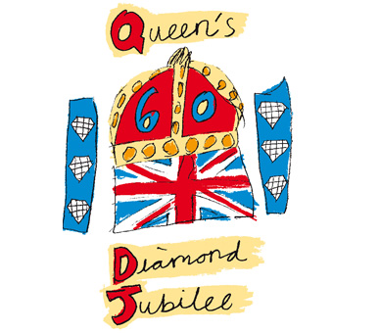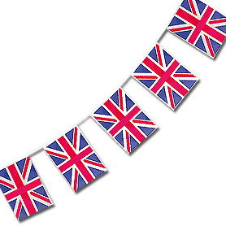

Saturday 2nd June: ‘Royal Family Day’

Tilsley House will be offering a chance to view classic Royal footage and DVD documentaries for all of our residents and guests to enjoy followed by a ‘high tea’ being served in our beautiful gardens. Be sure not to miss our traditional sing-a-long in the evening around our home’s piano.

Sunday 3rd June: ‘Best of British’

Join us for a traditional and delicious three course meal including roast beef at a small contribution of £5 per person. This will be followed by a trip to Clarence Park to participate in the Diamond Jubilee Celebrations being organised by St Paul’s Church and a chance for our residents and guests to dress formally in celebration.

Monday 4th June: ‘Kings and Queens’

Guests and volunteers are welcome to join us as we spend the day pampering our residents, just like Kings and Queens. We have our friendly therapist Ruth joining us for the day and will be spoiling our residents with massages and treatments.

Tuesday 5th June: ‘Diamond Jubilee Showcase’

Enjoy a day at Tilsley in which we will be broadcasting the Diamond Jubilee from our lounge and serving classic cream teas. There will be a ‘street party’ themed celebration in our gardens with decorations and snacks being served to all.

We would be delighted to see as many of you as possible. Join us in our 4-day celebrations and make these days fantastic for all at Tilsley House

Volunteers, visitors and guests are more than welcome!

Hope to see you there…

**Tilsley House Diamond Jubilee**

**Celebration (June 2012)**

Tilsley House is proud to be hosting 4 fabulous days of celebration for the Queen’s Diamond Jubilee in June 2012. Please see details below, we hope you can join us…